

Diesel Loco Shed Jhansi is the only Diesel Loco Shed in North Central Railway catering to traffic needs of Mail/Express, Passenger, Goods and Shunting services of diesel locomotives as well as Electric locomotives. The shed has completed 49 glorious years in the service of the nation in April’2024.

**ORGANIZATION CHART (GAZETTED)**

**CONTACT DETAILS OF OFFICERS**

|  |  |  |  |  |  |
| --- | --- | --- | --- | --- | --- |
| Name | Designation | Rly Phones | | BSNL Phones | |
| **Office** | **Residence** | **Office** | **Residence** |
| Lokesh Kailash Meena | DME/Diesel | 6301 | 55446 | - | - |

**ASSETS MAINTAINED BY DIESEL LOCO SHED, JHANSI**

**In addition, Diesel Loco Shed/ Jhansi has been nominated for AOH, IOH & POH Maintenance Schedule of 76 Tower Wagon of NCR.**

**MAN POWER STATUS**

|  |  |
| --- | --- |
|  |  |

**DUTY LIST OF OFFICERS OF DIESEL LOCO SHED, JHANSI**

**Shri Lokesh Kailash Meena, DME/ Diesel**

* To monitor the working of all the Heavy Repair Sections of Diesel Shed including for Electric Locos.
* Correspondence related to RSP, M&P, Works Program, Warranty and Performance Feedback of Loco Spares to RDSO / DLW.
* Initiation of Tenders of works contracts and AMCs of JHS Diesel Shed.
* Monitoring of activities DTC, DTH and Loco Simulator.
* Monitoring of ISO Cell.
* Monitoring of Staff Canteen of Diesel Shed.
* Monitoring of DMIC (Record Office) and failure analysis & completion of failure report.
* Material requirement planning and follow up with Head Quarter Stores, DLW, DMW and other sheds, workshops and Firms.
* Scrap disposal
* Monitoring of maintenance of M&P of Diesel Shed.
* To monitor following areas of working of Diesel Shed.
  1. Shed Laboratory.
  2. Machine shop including pit wheel lathe.
  3. Electrical and mechanical millwright sections.
  4. Fabrication.
* Any other work allotted by the Sr. DME/Diesel/JHS as per requirement.
* To monitor the following areas of working of Diesel Shed.
  1. Electrical HSR Section.
  2. Mechanical HSR.
  3. Main and shift tool rooms of mech. and electrical wings including gasket room.
* To plan and monitor Heavy Schedules (M18 / Y1 / TOH and above)
* To plan and monitor the Running Schedules (M6 /180 Days / IC and below) of all Locos.
* Failure Investigation.
* Monitoring of all works pertaining to establishment section of this office.
* Monitoring of office administration.
* To monitor the following areas of working of Diesel Shed.
  1. Electrical LSR section
  2. Mechanical LSR Section
  3. Shed Control Room,
  4. REMMLOT
  5. Loco Washing Pit, Sand shed and sand treatment plant.
  6. Load Box.
* To plan & Monitor the Passenger Links of JHS Shed.
* To plan & monitor the movement of outstation Dead / Failed / Overdue locos.
* To co - ordinate with the Diesel Trouble Shooting Points / Trip Sheds at JHS, GWL, CNB and PRYJ.
* To liaison with other Diesel Sheds, PRC/JHS, PRC/PRYJ and other Divisional and Zonal Power Controls wherever JHS Locos are running.
* Monitoring of Incinerator and ETP.
* Monitoring of RCD and liaison with M/s IOC.
* Any other work allotted by the Sr. DME/Diesel/JHS as per requirement.

**ACHIEVEMENTS**

**Good Work Done: Self-made test benches for electric loco -** For testing during maintenance work of electric locomotives, following test benches/ fixture/ gadgets have been prepared by the shed in house: -

|  |  |
| --- | --- |
| **EMC Test Bench for Electric locos -** For testing of AC Locomotive Equipment i.e., EM Contactor coil resistance, EM Contactor coil pickup & drop voltage. | C:\Users\DIESEL\Desktop\Innovation PICS\EMC Test Bench.jpeg |
| **EPC/EP Valve Test Bench for Electric locos -** For testing of AC Locomotive equipment i.e., Electro pneumatic valve coil resistance, coil pickup & drop voltage. | C:\Users\DIESEL\Desktop\Innovation PICS\EP Valve.jpeg |

|  |  |
| --- | --- |
| **CTF/ Reverser Test Bench for Electric locos -** For testing of AC Locomotive equipment i.e., Electro Pneumatic contactor, CTF Servo Motor, Reverser etc. | C:\Users\DIESEL\Desktop\Innovation PICS\CTF Reversor.jpeg |
| **MP Test Bench for Electric locos -** For testing of AC Locomotive equipment i.e., Testing of Conventional type MP. | C:\Users\DIESEL\Desktop\Innovation PICS\MP Test Bench.jpeg |
| **VCD Test Bench for Electric locos -** For testing of AC Locomotive equipment i.e., Testing of performance of Vigilance Control Device unit. | C:\Users\DIESEL\Desktop\Innovation PICS\VCD TB.jpeg |
| **VCB Test Bench for Electric locos -** For testing of AC Locomotive equipment i.e., Testing of Vacuum Circuit Breaker - various parameters. | C:\Users\DIESEL\Desktop\Innovation PICS\VCB T B.jpeg |
| **CHBA Test Bench for Electric locos –** For testing of AC locomotives equipment (simplified battery charger) |  |

**HRPT Test Bench for Electric Locos- For testing of AC Locomotives in house HRPT test bench is developed**

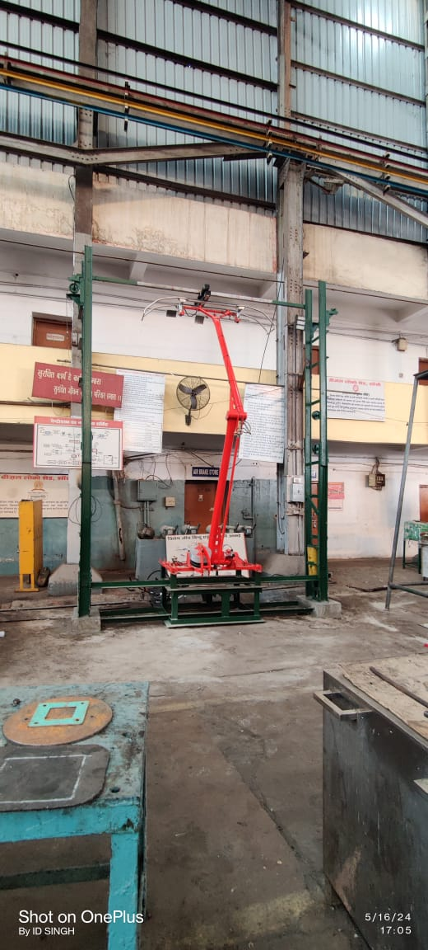

**Other Good work done in DLSJ**

|  |  |
| --- | --- |
| Loco 40408/WDP4D was stabled in shed from 25 sep’2021 due to SCR assembly failure. This SCR assembly would cost about ₹26.5 Lakh, but with the efforts of shed this problem of SCR assembly is resolved with only ₹12500, now loco is working properly. Net saving ₹ 26 Lakh approx. |  |

* After the shed-in of AC loco, Pre-inspection is done outside the pit & scheduled inspection is done inside the pit. As Loco is cranked for BPT adjustment which was earlier done outside the pit. So by LSR/mech in-house BPT Machine was made to reduce the BPT adjustment time. With the help of the BPT machine, BPT adjustment time is reduced by 8 Hrs.
* Loco No. 36263 & 36266 worked on the CRDI system. Due to the failure of the CRDI system, its maintenance was not able to be done so it was left unattended for 7-8 months. Finally, with the guidance of the SSE/LSR/Mech CRDI system, these locos were converted into a Complete conventional system. Now, these Locos are working normally on the Conventional System Type.
* Plunger Testing:- For testing of plunger after overhauling an in house fixture made on HRPT Test bench. With the help of this fixture, 10 kg Load was applied to the plunger to check the displacement. It should not be more than 25mm**.**
* Servomotor Spring Removing Fixture- There was no facility in the shed to remove the complete spring assembly in case of damage or broken spring. Also, in case of trouble in the mechanism while changing the oil seals. To overcome this problem a fixture is made in-house using scrap material.

**DISPOSAL OF SCRAP**

|  |  |  |  |  |
| --- | --- | --- | --- | --- |
| Year | Scrap Target (MT) | Ferrous Scrap Disposal (MT) | Non-Ferrous Scrap Disposal (MT) | Total Scrap Disposal (MT) |
| **2021-22** | **320** | **1266.71** | **136.65** | **1403.36** |
| **2022-23** | **330** | **1045.73** | **76.2** | **1121.93** |
| **2023-24** | **65** | **189.493** | **5.233** | **194.726** |
| **2024-25** | **282.16** | **902.565** | **84.726** | **987.297** |
| **2025-26(till 11.08.25)** | **142** | **105.04** | **4.458** | **109.498** |

* **In 2025-26(till 11.08.25) Out of 248 Batteries 171 Batteries were condemned and disposed.**

**ACTION PLAN FOR SYSTEM IMPROVEMENT**

* Sharing of manuals, and maintenance literature online through Google drive.
* Various drives conducted proactively covering locomotives in the shed during maintenance to improve reliability for failure-prone areas.
* Cross-section audit teams of supervisors are formed for conducting section audits as per schedule.
* Counseling of staff related to safety and giving maintenance guidelines to ensure quality work according to SMI and RDSO.
* Training of staff on AC loco maintenance, critical circuit diagrams, loco safety checks, and others are conducted in DTC on regular basis.

**In order to reduce the failures and improving reliability of locomotives, various drives have been launched. The details of Ongoing drives**

* Drive for checking of chassis crack in WDM3D locos.
* One round drive for checking TSC sound & performing TCA clutch test.
* Golden safety drive for under frame equipment of AC locos.
* One time drive to overhaul LRU (BPCP, 20CP, & ERCP) valve in CCB2.0 HHP locos.
* Summer Drive of AC locos
* Summer Drive of DIESEL locos

**Completion of drive from 01 Apr’2025 to 08 May’2025**

* Week long safety drive for the month of April'2025 **Locomotives**: Drive such as adequate level of suspension bearing oil and its filling cap, cardium compound in gear case and its cover, felt wick carrier screw and its sealing and mounting brackets and strength of under frame equipments.  
  To ensure checking of CBC including APMs, knuckle, lock lifter assembly, knuckel pin, Anit roatation lug, coupler head etc. condition of operating handle, including bends, wear of bolts, corrosion in brackets, groove in bore of bracket etc. condition of supporting device and its springs.all the guage for wear measurement in CBC along with calibration records of these guages for concurrency. side buffers in locomotives for height, dropping, and crack in the casting, completeness of bolts securing them with the rolling stock.
* Week long safety drive for the month of May'2025 to check availability of safety equipment in locomotives such as wooden wedges, fire extinguisher, sand, BP FP hase pipe and spare coupling etc.

Above roof drive such as cleaning, defect in Panto and any other defect.

* Summer Drive Monsoon Drive of AC locos
* Summer Drive of DIESEL locos
* Week long safety drive for the month of June’2025

Traction: Summer drive, which includes temperature checking of axle box, MSU and TM bearing through Infrared temperature gun on arrival of locomotive at destination station/ out pit, checking for any oil leakage from transformer, Tap changer (GR), MPH circuit, traction converter, oil pump etc.

* Safety of underslung equipment in rolling stock.

* One round drive for checking TSC sound & performing TCA clutch test.
* Week long safety drive for the month of July’2025 TRACTION:- Monsoon drive, which includes working of wiper, condition of silica gel, topping up of water in batteries, sander working or not e.t.c.

**Ongoing Drives list**

* Drive for checking of chassis crack in WDM3D locos.
* Golden safety drive for under frame equipment of AC locos.
* One time drive to overhaul LRU (BPCP, 20CP, & ERCP) valve in CCB2.0 HHP locos.
* Monsoon Drive of DIESEL locos
* AC Loco Monsoon Drive
* One time drive to check Air dryer working or not working in every locos.
* One time drive for checking throttle control coupler pin IR>1M ohms (28 pin) in HHP locos.
* Special drive checks for improvement in reliability of HHP Locomotives.
* Week long safety drive for the month of August’2025 TRACTION:- Drive for working of Air dryer, sanders and wipers etc.

**FACILITIES AT DIESEL SHED /JHS**

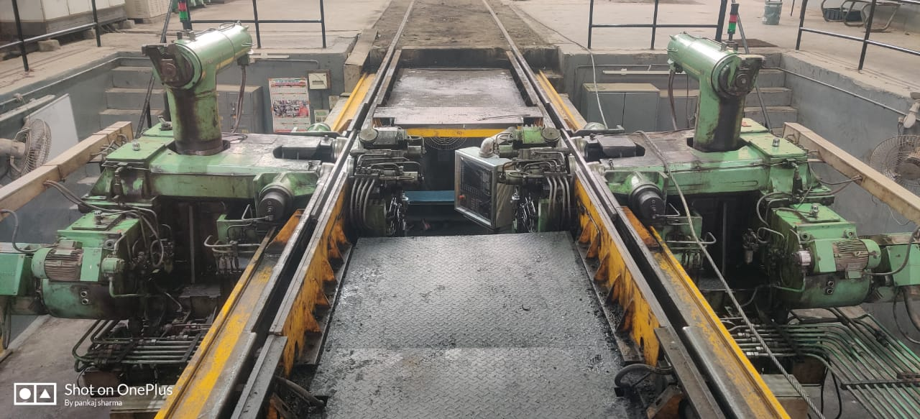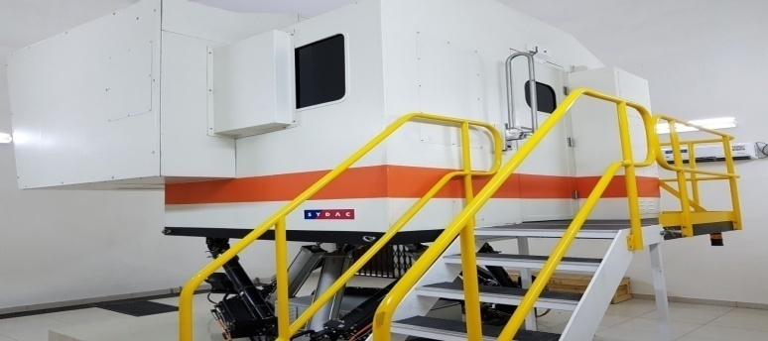

**PIT WHEEL LATHE**

**SIMULATOR**

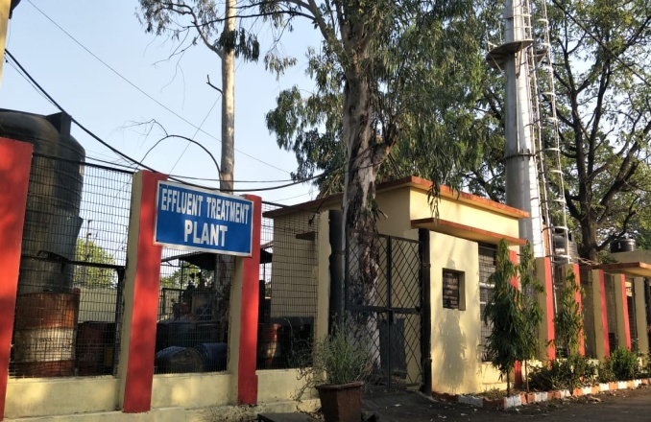

**EFFLUENT TREATMENT PLANT**

DTC (Diesel Training Centre), Diesel Loco Shed Jhnasi

* **Estabilished in 1989**
* **Capacity 100 trainees.**
* **Training is given: LP/ALP/CLI & Maintenance Staff of Diesel Locomotive**

|  |  |
| --- | --- |
| **YEAR** | **STAFF TRAINED** |
| **2022-23 (Upto 31 Mar)** | **1366** |
| **2023-24 (Upto 31 Mar)** | **1149** |
| **2024-25( Upto 31 Mar)** | **1312** |
| **2025-26 ( Upto 11 Aug)** | **552** |

* **Facilities at DTC**
  + **Simulator**
    - **HHP Type WDG4 Locomotive**
  + **Conventional loco WDM2 Model Room**
  + **AC Loco Model Room With WAG7 Loco Elect. Component**

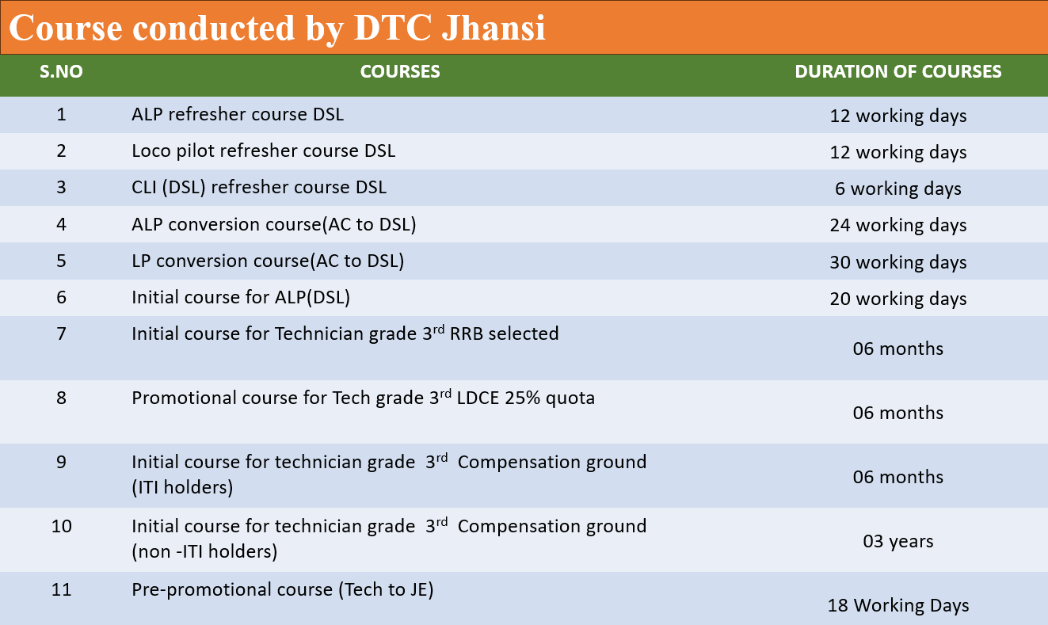

* **Year wise staff trained by DTC/JHS (Running Staff)**
* **Course wise staff trained by DTC/JHS (Running staff) 2025-26 (up to 11th Aug 2025)**
* **Year wise staff trained by DTC/JHS (Maintenance staff)**
* **Course wise staff trained by DTC/JHS (Maintenance staff) 2025-26 (up to 11th Aug 2025)**